



**‘All disease begins in the gut’ Hippocrates**

**VEGAN • GLUTEN FREE • LACTOSE FREE • NO ADDED FAT • NO ADDED SUGAR • NO ADDED SALT**

Never in the recorded history the human body had to break down and eliminate the amount of chemicals, herbicides, pesticides, GMO, heavy metal and toxins that it does today.

Yes, these are alarming news! However, there are effective strategies to reduce these negative influences. We can enhance our health and the quality of our lives through changes in lifestyle, healthy eating and effective detoxification strategies. Today humanity is facing Lifestyle illnesses: **diabetes, leaky gut syndrome, Dementia, Alzheimer, IBS,** **joint pain issue, high blood pressure, fatigue, sleeping disorders, stress, etc.**

Typical “Western lifestyle” with its processed foods, absence of healthy whole meals, reliance on medications and antibiotics, common use of alcohol and drugs, environmental pollutants, and high stress levels and even too much exercise overtraining as well as high amounts of emotional or physical stress can generate free radicals. Free radicals steal electrons from us and create our cells unable to functional as they should!

They all have one common thing…they are called LIFESTYLE diseases. Viruses do not cause them; so, we have no one else to blame that our lifestyle, environment we are living, air we are breathing and food that we are consuming!

The problem is not so much in INTAKE, the problem is in **RELEASE!**

We cannot get rid of bad things that accumulates in our bodies! **WHY?**

WHAT ARE LIFESTYLE ILNESSES?

Stress, heart disease, high blood pressure, joint pains, arteriosclerosis, Alzheimer, leaky gut, sleep disorder, cirrhosis, diabetes, cancer, stroke etc.

**EXPLANATION.**

Unfortunately, as a result of intensive farming, which has already basically violated the principles of natural rejuvenation and its reproduction. Microbes, humic and fulvic acid, have been destroyed by the use of chemical fertilizers and by not allowing the land to recover. The soil is depleted, it cannot provide a healthy environment for bacteria, which results in a weakening of the body without a healthy diet.

As a comparison, we can say that the earth's artificial fertilizers are the same as chemical medications for us! Neither one of them in the long run does not solve the problem, but it causes a direct harm to our organism, as well as to agricultural land.

With modern medicine we try to prevent the consequences but forget to cope with the causes!

**WHY WE NEED BLACK STUFF?**

BLACK STUFF is a natural compound of Polyphenols derived from lignin. It provides the body with the ability to absorb and administer nutrients, antioxidants, fatty acids and minerals at a cellular level. BLACK STUFF aids in keeping your body healthy and well-balanced by removing free radicals, heavy metals, environmental toxins, dead cells and viruses from the body.

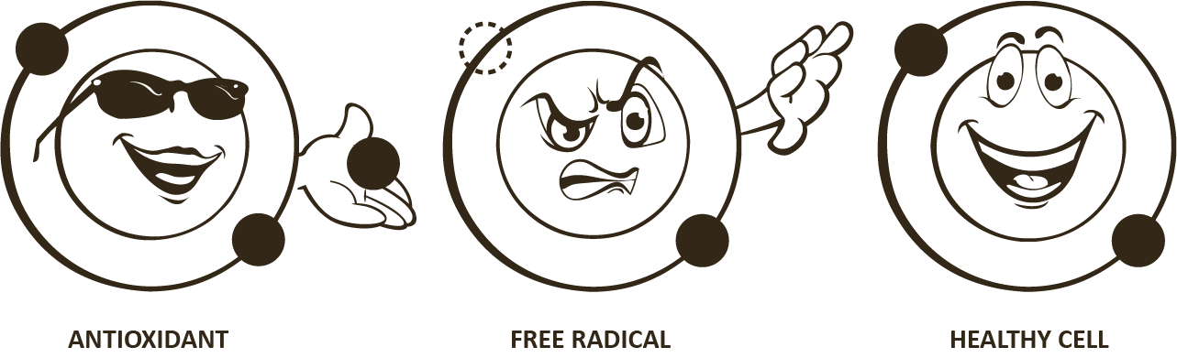

**SUGGESTED USAGE.**

We recommend 1 capsule (0.5 g) per day, regardless of whether you are trying to fix a health problem or just maintain a healthy lifestyle. A higher dose is not needed, as the body simply does not consume more than necessary.

**WHAT IS THE DURATION OF USING BLACK STUFF?**

We believe that BLACK STUFF should be part of your daily life, because with our daily diet we are not able to absorb enough acids, which are the transport units in our body, to ensure the full functioning of the chemical processes in our body and maintain our health without artificial drugs.

**WHAT ARE THE MOST COMMON RESULTS EXPECTED WITH BLACK STUFF?**

• Improves gastrointestinal performance GI;

• Gives energy;

• Eliminates sleep disturbances;

• Isolates toxins from the body (may appear as pimples for teenager for a few days)

• Removes joint pain;

• Stabilizes blood sugar, etc.

**WHAT IS A MICROBIOME?**

A microbiome refers to the collective genomes of microorganisms in a particular environment, and a microbiota is a community of microorganisms themselves. About 100 trillion microorganisms exist in the human gastrointestinal tract GI.

**MICROBIOME IN NUMBERS.**



**INGREDIENTS.**

Polyphenols**,** Fulvic Acid**, Humic acid,** Microelements.

**POLYPHENOLS.**

Phenols improve health because of they are extremely potent antioxidants. They neutralize the destructive reactivity of undesired oxygen radicals produced as by-product of cellular metabolism. As such, they improve cellular health which benefits just about every system in the body. Antioxidants are also especially important for the immune system to function optimally!

Phenols are part of the plant's natural defense against ultraviolet radiation **UV** from the Sun. Epidemiological studies strongly suggest that long term consumption of diets rich in plant polyphenols offer protection against development of cancers, cardiovascular diseases, diabetes, osteoporosis and neurodegenerative diseases. In BLACK STUFF, the largest part of phenols is one of the simplest compounds in the phenol group — quinones.

[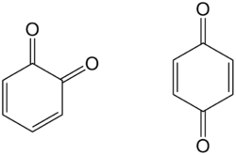](https://lv.wikipedia.org/wiki/Att%C4%93ls:Chinonen_algemeen.png)

**FULVIC ACIDS.**

Fulvic acids are one of the safest and most powerful antiviral substances known. Although they are not antibiotics in the technical sense of the word, as prescription drugs are, their antibiotic-like effect is comparable to the power of penicillin in equally small amounts. Unlike antibiotics, fulvic acids may be used indefinitely without creating any antibiotic resistant strains of disease which are common problems with pharmaceutical drugs.

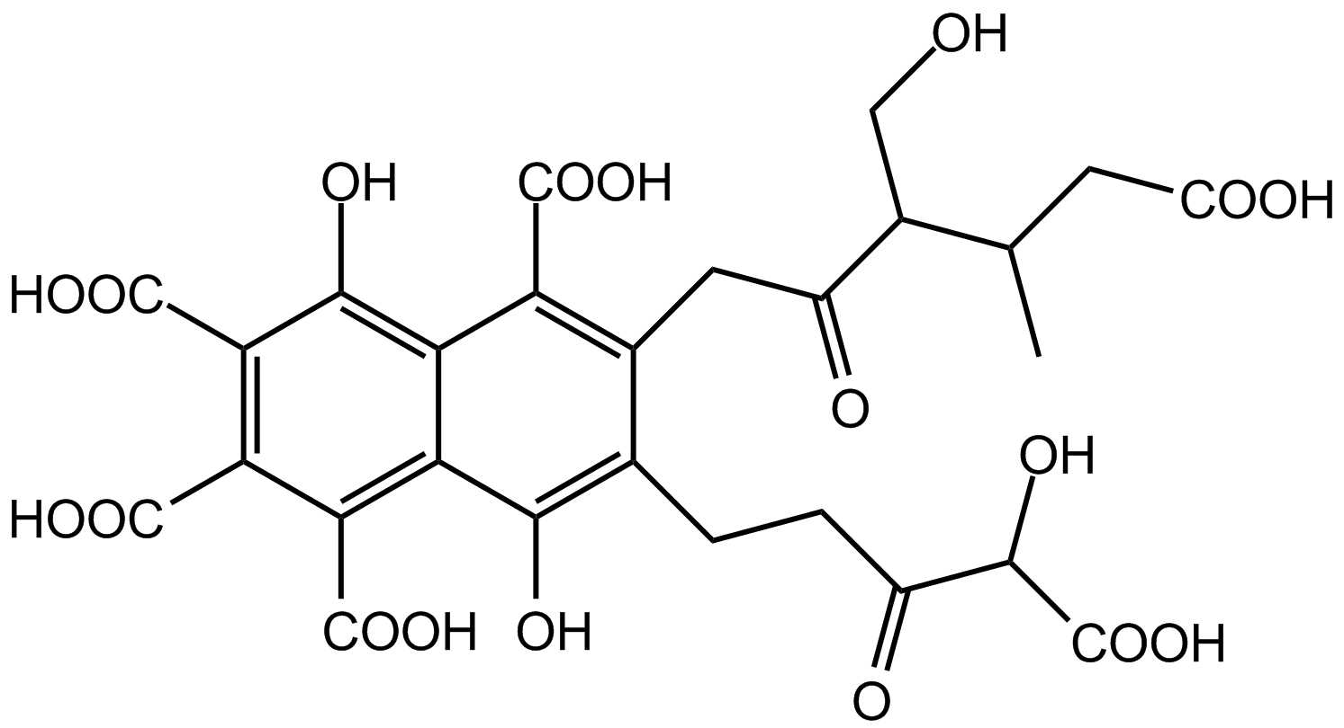

**MICROELEMENTS.**

**Cobalt** is known to influence iron metabolism and increase the hemoglobin concentration in red blood cells.

**Copper** has a significant role in the formation of red blood cells. It is required to absorb, utilize and synthesize hemoglobin, which is necessary for red blood cell formation. Copper helps to maintain the integrity of the outer covering of the nerves, metabolize vitamin C and utilize fatty acids for energy.

**Iron** is the basic component of hemoglobin, the oxygen-carrying protein found in red blood cells. It is also an essential component in the electron transporting cytochromes, which are found in the mitochondrial membrane, the site of energy synthesis.

**Magnesium** is involved in more than 300 enzyme reactions in the body. One of its most important roles is maintaining the function of the nervous system and neuromuscular transmission and activity.

**Manganese** is involved in protein, fat, and energy metabolism. It is also required for bone growth, development and reproduction. Its deficiency can cause dermatitis, pigment disturbances of hair, growth problems, and infertility.

**Molybdenum** functions as an enzyme cofactor in many biochemical reactions. It also acts as an electron transfer agent in oxidation-reduction reactions.

**Potassium** is an essential element in maintaining fluid balance in our cells, contributing to the transmission of nerve impulses, the control of skeletal muscle contractility, and the maintenance of normal blood pressure.

**Selenium** is a trace element with a number of biological effects, although it is best known as an antioxidant because of its relationship with vitamin E. There is evidence that selenium may be protective against certain cancers. Selenium is also thought to be protective against the effects of toxic elements, such as arsenic, mercury, and cadmium by binding these metals.

**Zinc** is essential for the functioning of over 200 enzymes in biologic systems. A critical function of zinc is its role in the structure and function of bio-membranes. It is also responsible for the synthesis of DNA and RNA. Furthermore, zinc is involved in immunity, wound healing, and the functioning of the central nervous system. The presence of zinc is especially important in preventing toxicity of metal ions, such as lead, arsenic, and cadmium.

**STORAGE CONDITIONS.**

Store tightly closed in a dry place. Prevent direct contact with light as it may cause the product to discolor and lose nutritional value. Keep away from children.

 